**PF Lab assignment 7**

# **Question 1**

**Write a C Program that takes an user input array and prints the sum of its elements.**

**Code**

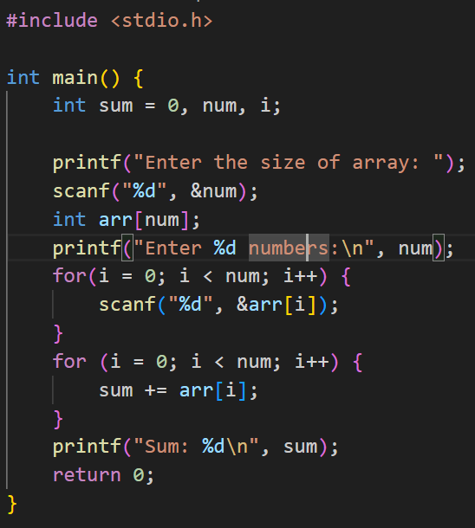

**Output**

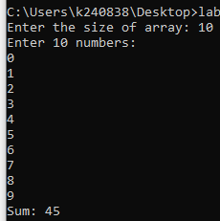

# **Question 2:**

**Write a program in C to read n number of values in an array and display it in reverse order**

**Code:**

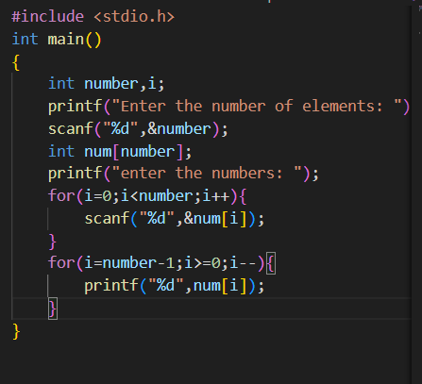

**Output:**

# **Question 3:**

**Write a C Program to find the minimum and maximum number in an array.**

­­­­­­­­­­­**Code:**

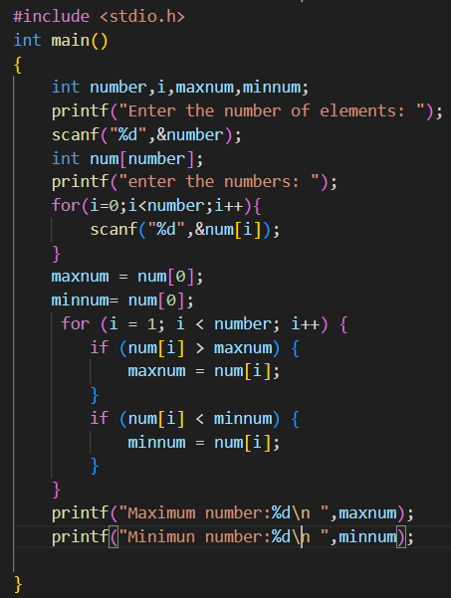

**Output:**

# **Question 4:**

**Given an array arr[] of size N which contains elements from 0 to N-1, you need to find all the elements occurring more than once in the given array.**

**Code:**

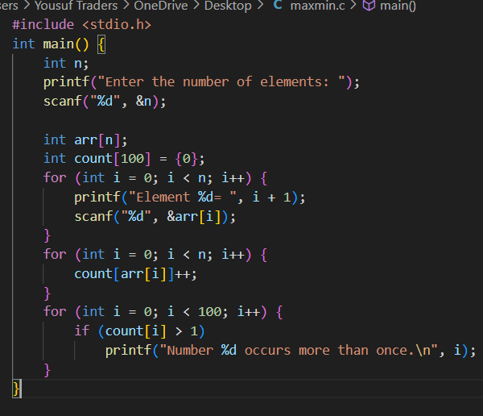

**Output:**

